**Week 5 assignment**

**Problem 1**

I create a Library for risk management, which contains missing_data.py, EWMA.py, nearpsd_higham.py, chol.py, simulation.py, returns_fit_var_es.py.

In compare_results.py, I test the functionality of these methods by using compare_results function, showing that my output was close to the expected outcome to a few decimal places.

Test1-8:

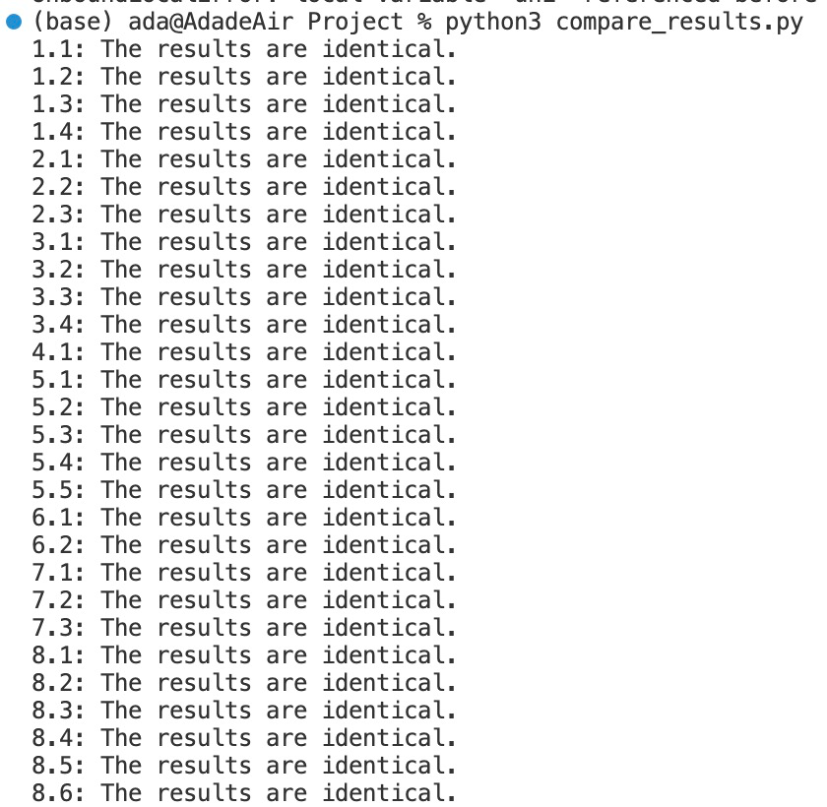

Test 9:

My outcome is similar to the expected outcome

My outcome:

|  |  |  |  |  |
| --- | --- | --- | --- | --- |
| Stock | VaR95 | ES95 | VaR95_Pct | ES95_Pct |
| A | 93.13115393 | 115.7573155 | 0.046565577 | 0.057878657 |
| B | 108.6059319 | 153.9765949 | 0.036201977 | 0.051325531 |
| Total | 152.2533105 | 202.8261729 | 0.030450662 | 0.040565234 |

Expected outcome:

|  |  |  |  |  |
| --- | --- | --- | --- | --- |
| Stock | VaR95 | ES95 | VaR95_Pct | ES95_Pct |
| A | 94.46037635 | 118.2893708 | 0.047230188 | 0.059144685 |
| B | 107.8804274 | 151.2181736 | 0.035960142 | 0.050406058 |
| Total | 152.5656843 | 199.7045322 | 0.030513137 | 0.039940906 |

**Problem 2**

By applying the library, answers are as followed.

|  |  |  |
| --- | --- | --- |
|  | VaR | ES |
| Using a normal distribution  with an exponentially weighted variance | 0.09110379 | 0.11512766 |
| Using a MLE fitted T distribution | 0.07647603 | 0.11677670 |
| Using a Historic Simulation | 0.07598069 | 0.11677670 |

**Problem 3**

To compare the results from this week and from week4, I use Portfolio.csv and DailyPrices.csv from week4, the result are as follows:

Myoutput_risk_A

|  |  |  |  |  |
| --- | --- | --- | --- | --- |
| Stock | VaR95 | ES95 | VaR95_Pct | ES95_Pct |
| AAPL | 773.6886144 | 1156.780216 | 0.028015124 | 0.041886802 |
| MSFT | 1783.573657 | 2527.495676 | 0.031608077 | 0.044791689 |
| AMZN | 566.4872049 | 810.8464343 | 0.039884479 | 0.057088999 |
| NVDA | 1100.422569 | 1657.890276 | 0.048974274 | 0.073784358 |
| GOOGL | 296.7981605 | 436.6996682 | 0.033024358 | 0.048591023 |
| TSLA | 915.3863939 | 1248.869698 | 0.062301697 | 0.084998753 |
| GOOG | 729.3062984 | 1066.520478 | 0.03327317 | 0.048657906 |
| BRK-B | 1172.255828 | 1727.078669 | 0.017593619 | 0.025920592 |
| META | 1076.926614 | 1786.920827 | 0.042866643 | 0.071127685 |
| UNH | 668.549999 | 1034.385152 | 0.021655475 | 0.0335055 |
| XOM | 212.6158624 | 280.4194394 | 0.027202922 | 0.035877982 |
| LLY | 2543.023951 | 4125.043266 | 0.023211784 | 0.037651872 |
| JPM | 519.6411572 | 806.229224 | 0.023305754 | 0.036159145 |
| JNJ | 204.1157325 | 308.0101315 | 0.016304476 | 0.024603413 |
| V | 270.1425387 | 394.973218 | 0.020520563 | 0.030002948 |
| PG | 178.2606116 | 249.4548444 | 0.016109818 | 0.022543803 |
| MA | 1433.427216 | 2070.692983 | 0.021598721 | 0.031200971 |
| AVGO | 3830.572291 | 5504.707175 | 0.032767862 | 0.047088913 |
| HD | 1315.79434 | 1856.263258 | 0.02502197 | 0.035299865 |
| CVX | 575.7014887 | 825.4799141 | 0.024908211 | 0.035715086 |
| MRK | 120.9915427 | 169.2805922 | 0.0196169 | 0.02744622 |
| ABBV | 207.9120187 | 304.5067372 | 0.020017871 | 0.029318058 |
| COST | 2178.864267 | 3404.615814 | 0.021315028 | 0.033306105 |
| PEP | 497.8601393 | 701.9959786 | 0.016709015 | 0.023560153 |
| ADBE | 2859.119721 | 4194.361129 | 0.036197527 | 0.053102184 |
| WMT | 199.1479285 | 285.210529 | 0.015527316 | 0.02223751 |
| KO | 70.16872029 | 98.33460253 | 0.015420342 | 0.021610102 |
| CSCO | 188.7515794 | 272.9666247 | 0.02060501 | 0.029798321 |
| CRM | 891.3294875 | 1275.810148 | 0.033998656 | 0.048664194 |
| MCD | 269.5634555 | 386.3310815 | 0.015718114 | 0.022526777 |
| ACN | 475.9898195 | 671.8990157 | 0.025963242 | 0.036649264 |
| BAC | 56.00349098 | 79.75069073 | 0.028945365 | 0.041219089 |
| TMO | 1212.050579 | 1664.598328 | 0.025645209 | 0.035220455 |
| Total | 20176.49854 | 27729.97235 | 0.018522169 | 0.025456312 |

Myoutput_risk_B

|  |  |  |  |  |
| --- | --- | --- | --- | --- |
| Stock | VaR95 | ES95 | VaR95_Pct | ES95_Pct |
| CMCSA | 59.8772829 | 90.53210049 | 0.025419122 | 0.038432715 |
| PFE | 69.70299309 | 96.9320745 | 0.023691579 | 0.032946561 |
| LIN | 761.1521524 | 1184.431846 | 0.021483115 | 0.033429959 |
| ORCL | 310.0619677 | 476.979587 | 0.025166571 | 0.03871465 |
| ABT | 247.3774838 | 345.4714091 | 0.023122956 | 0.032292027 |
| NFLX | 1080.512569 | 1719.3515 | 0.044451197 | 0.070732385 |
| DHR | 488.6349187 | 709.6890216 | 0.027324541 | 0.039685921 |
| AMD | 376.5882373 | 545.1823775 | 0.050187676 | 0.072656111 |
| WFC | 196.9212303 | 279.6917797 | 0.029665613 | 0.042134757 |
| DIS | 469.5257121 | 686.6334668 | 0.032833966 | 0.048016326 |
| PM | 171.2326683 | 239.9548795 | 0.018219982 | 0.025532357 |
| TXN | 823.5196268 | 1088.933266 | 0.028539137 | 0.037737068 |
| INTC | 114.7578849 | 154.968925 | 0.040944599 | 0.055291543 |
| AMGN | 371.6411969 | 589.0324035 | 0.023137914 | 0.036672418 |
| COP | 453.9430437 | 655.4615882 | 0.034013618 | 0.049113255 |
| INTU | 1287.706198 | 1807.905647 | 0.037235495 | 0.052277656 |
| VZ | 147.4182083 | 215.7281074 | 0.022148169 | 0.032411075 |
| CAT | 1001.272725 | 1450.374294 | 0.02842527 | 0.041174876 |
| NEE | 119.0889537 | 172.3820059 | 0.025493751 | 0.036902364 |
| IBM | 183.3315931 | 267.5430979 | 0.018351731 | 0.026781412 |
| UNP | 284.280858 | 426.3425278 | 0.025634628 | 0.038444841 |
| HON | 658.6942231 | 927.8181749 | 0.021163601 | 0.029810454 |
| BMY | 189.040113 | 258.0061066 | 0.019690242 | 0.026873676 |
| LOW | 910.2402539 | 1342.781774 | 0.027899271 | 0.041156863 |
| GE | 187.0014042 | 266.9504567 | 0.025468356 | 0.036356889 |
| SPGI | 1112.488754 | 1576.966493 | 0.025364876 | 0.035955024 |
| QCOM | 807.6778531 | 1115.368647 | 0.038663521 | 0.053392672 |
| AMAT | 289.4504985 | 398.2930077 | 0.03936399 | 0.054166091 |
| BA | 1046.373251 | 1675.750685 | 0.03131636 | 0.050152669 |
| UPS | 759.7961164 | 1090.712109 | 0.026141795 | 0.0375274 |
| NKE | 406.778585 | 612.137751 | 0.031755141 | 0.04778649 |
| NOW | 1417.097953 | 2048.607738 | 0.037610631 | 0.054371281 |
| T | 44.20504473 | 68.5636838 | 0.025645737 | 0.039777502 |
| Total | 11806.45626 | 16053.88274 | 0.020549321 | 0.027942033 |

Myoutput_risk_C

|  |  |  |  |  |
| --- | --- | --- | --- | --- |
| Stock | VaR95 | ES95 | VaR95_Pct | ES95_Pct |
| GS | 430.2117005 | 549.6142246 | 0.025231942 | 0.032234908 |
| BKNG | 11751.48632 | 14930.05945 | 0.029291373 | 0.037214181 |
| MS | 308.1119252 | 386.1228349 | 0.027606468 | 0.034596154 |
| MDT | 209.0173046 | 261.1632914 | 0.025280856 | 0.031587966 |
| SBUX | 437.8559381 | 535.1125251 | 0.02733306 | 0.033404281 |
| ELV | 1506.78935 | 1876.80049 | 0.026747138 | 0.033315235 |
| PLD | 532.5471811 | 657.4284386 | 0.029736305 | 0.036709409 |
| RTX | 350.4084844 | 435.9103718 | 0.025364459 | 0.031553547 |
| DE | 627.9875312 | 797.7834278 | 0.027946167 | 0.035502279 |
| TJX | 292.0507637 | 372.8031959 | 0.019382133 | 0.024741319 |
| ISRG | 650.1038657 | 826.8906172 | 0.033172625 | 0.042193462 |
| ADP | 859.0792471 | 1068.363143 | 0.023156242 | 0.028797432 |
| MMC | 323.3468731 | 407.1282251 | 0.019688853 | 0.024790367 |
| MDLZ | 164.4931241 | 207.2716089 | 0.017828663 | 0.022465228 |
| SYK | 1381.473106 | 1738.836964 | 0.02562178 | 0.032249704 |
| BLK | 1641.040547 | 2070.994002 | 0.029952391 | 0.037799933 |
| GILD | 320.3360873 | 401.7681524 | 0.024403305 | 0.030606825 |
| LMT | 690.1129767 | 881.8400435 | 0.020854375 | 0.026648134 |
| CVS | 219.605408 | 277.4547279 | 0.027314275 | 0.034509508 |
| VRTX | 1587.166449 | 1998.979191 | 0.025654571 | 0.032311011 |
| AXP | 512.6919481 | 637.9921703 | 0.030172761 | 0.037546885 |
| REGN | 4498.565511 | 5720.720084 | 0.031525227 | 0.04008989 |
| CB | 893.8601481 | 1129.631201 | 0.022078689 | 0.027902325 |
| ADI | 742.1841484 | 930.3643679 | 0.0306482 | 0.038419027 |
| CI | 1151.479387 | 1453.286162 | 0.02502076 | 0.031578788 |
| ETN | 518.5921927 | 665.5946025 | 0.025402059 | 0.032602638 |
| SLB | 392.3835294 | 500.2726088 | 0.038416546 | 0.048979491 |
| PGR | 750.5584503 | 949.8394157 | 0.030109971 | 0.038104477 |
| SCHW | 364.5697508 | 459.3057715 | 0.041838684 | 0.052710761 |
| LRCX | 5246.772139 | 6759.066797 | 0.043684027 | 0.05627522 |
| ZTS | 646.9831827 | 804.8916819 | 0.030263576 | 0.037649975 |
| C | 95.56012474 | 122.8930945 | 0.028136043 | 0.036183767 |
| BSX | 197.006294 | 253.4872917 | 0.019550482 | 0.025155536 |
| AMT | 351.551982 | 441.0493898 | 0.031104518 | 0.039023044 |
| Total | 26260.82776 | 33711.83506 | 0.018927957 | 0.024298403 |

Total

|  |  |  |  |  |
| --- | --- | --- | --- | --- |
| Stock | VaR95 | ES95 | VaR95_Pct | ES95_Pct |
| A | 20176.49854 | 27729.97235 | 0.018522169 | 0.025456312 |
| B | 11806.45626 | 16053.88274 | 0.020549321 | 0.027942033 |
| C | 26260.82776 | 33711.83506 | 0.018927957 | 0.024298403 |
| Toal | 58243.78256 | 77495.69015 | 0.057999447 | 0.077696748 |

**VaR from weel4:**

Portfolio A VaR: $15253.97

Portfolio B VaR: $7765.47

Portfolio C VaR: $17933.67

Total VaR: $38091.10

The result is larger.

If I use the dataset this week, the results are as follows:

Total

|  |  |  |  |  |
| --- | --- | --- | --- | --- |
| Stock | VaR95 | ES95 | VaR95_Pct | ES95_Pct |
| A | 8010.421658 | 10565.423037 | 0.026706 | 0.035224 |
| B | 6892.734897 | 9167.522369 | 0.023414 | 0.027942033 |
| C | 5934.79124 | 7504.778036 | 0.021977 | 0.027791 |
| Toal | 20837.947795 | 27237.723442 | 0.072097 | 0.090957033 |

The dataset is different, so we cannot campare.